The **Zscaler Test – AnyConnect Profile** – Switcher utility was created to allow Windows laptops to disconnect from the VPNs while maintaining internet connectivity in support of Zscaler Pilot Phase.  The utility has been made available to your Microsoft Windows laptop for install via SCCM.

Should any issues arise, and need to switch back to **A0VPN** -

* Launch the **Zscaler** client from the Start Menu
* Within the Zscaler Client Connector, click **TURN OFF** button for both the Private Access and Internet Security services.  
   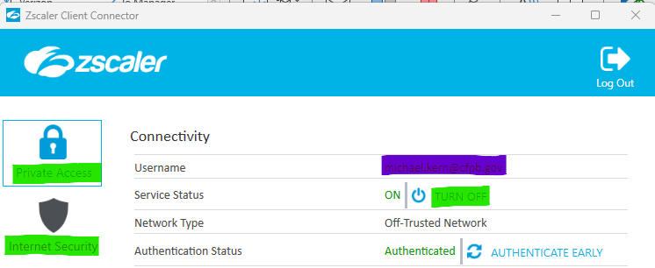
* Within the **Cisco AnyConnect Security Mobility** Client window, click **Connect**.  If you do not see the Cisco AnyConnect Security Mobility Client, it can be launched from the Start Menu.

If you have any additional questions or comment on the test script, please submit a RITM and assign the task to the **Zscaler Pilot** Assignment group.